Class: Mars

Term: Spring 2
This is our new homework grid, which is for this half term. You can complete any of the activities on the grid and then bring it into school to share with us; photograph, video, show or tell. The choice is yours. As always … if you are not sure, find an activity difficult or want to tell us anything … see your teacher so that we can help, or come along to our Homework Club after school on a Wednesday.
This half term our topic is: Growth and Green fingers.

The children will be learning about plants and their structures.

Design a poster that shows what a plant needs to be healthy. | Create an observational drawing of a wild plant in your garden or on the park. | Write a list, take a photo or draw a selection of 2D and 3D shapes found in your garden.
Try new fruits and vegetables and create a fruit kebab or a smoothie. If you would like to take a picture you can email it to us. | 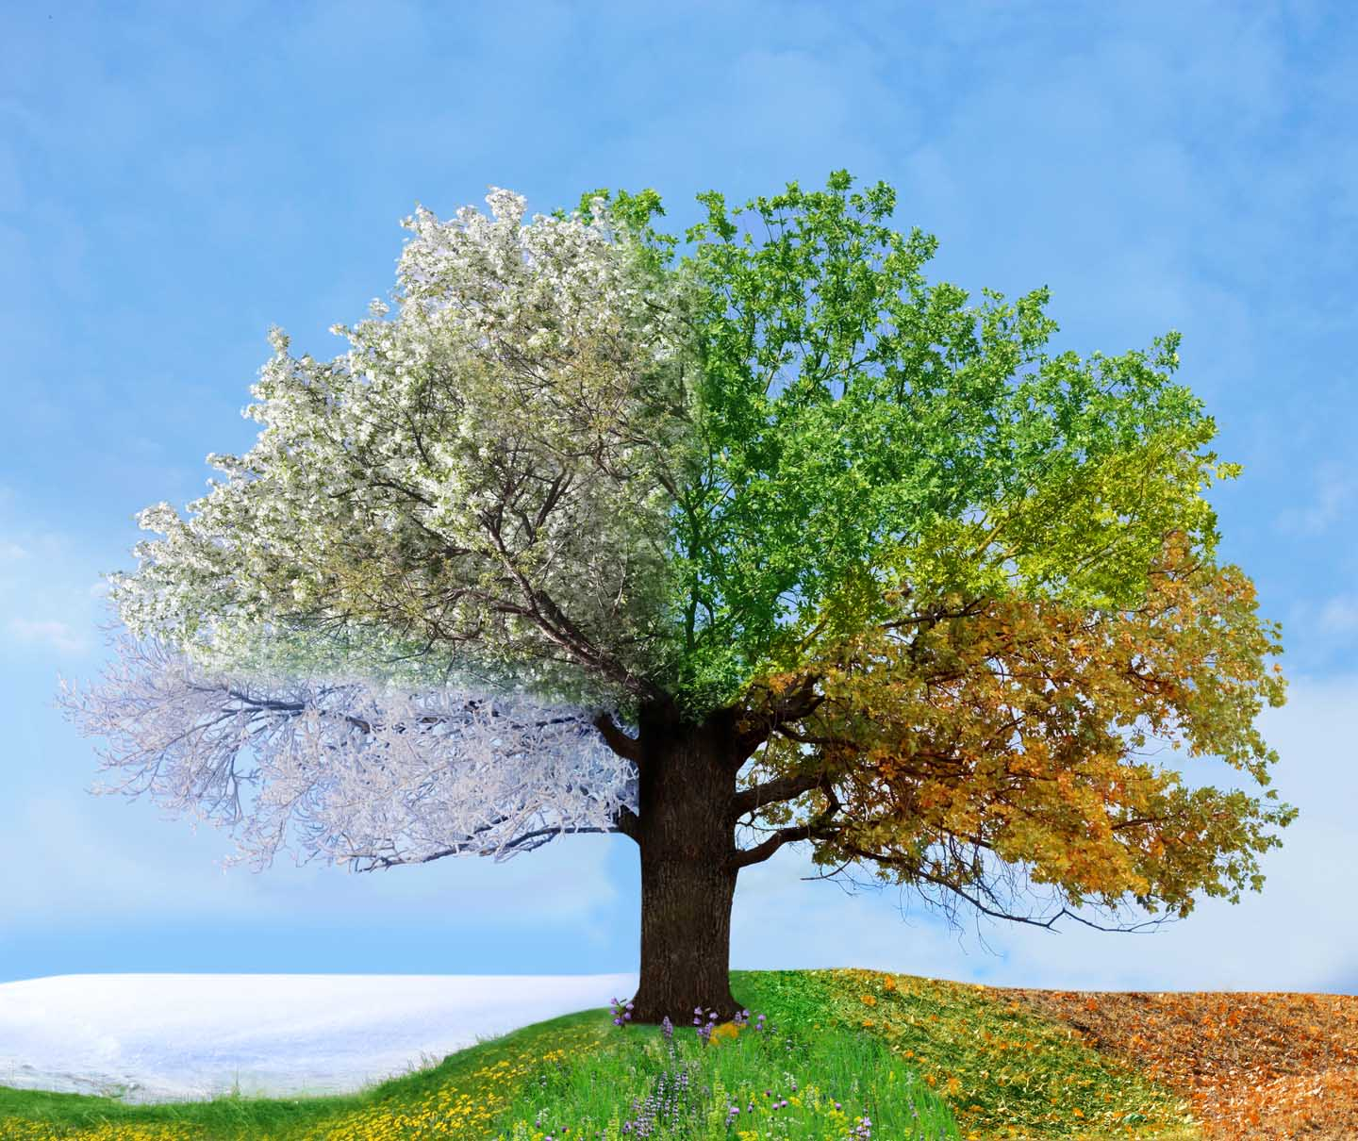 | Go for a walk and make a list of the seasonal changes you can see. Spring brings new life to plants and animals. Take photos or draw a picture and write about what you saw.
Plant a seed at home and keep a record of how it grows each week. | Make a model tree out of recyclable household materials or sticks you find on a walk. | Write about your favorite fruit and vegetables and explain why you like them.
The tasks below should, if possible, be done every week as well as a task chosen from the list above.

Reading  Please share the school (and library) book in your child’s reading folder every night and use the reading record to sign when they have done this.  They love to receive their dojos from reading!  Suggested timing: 10mins daily | English  Visit the school website and play some of our English games.  Practice your weekly spelling rules on spelling shed or try some of the yearly word lists.  Suggested timing: 15 mins | Mathematics  Visit the school website and play some of our Math’s games.  Practice your timetables on TT Rock stars. There are also some great games on Top marks. Remember to challenge yourself!  Suggested timing: 15 mins

