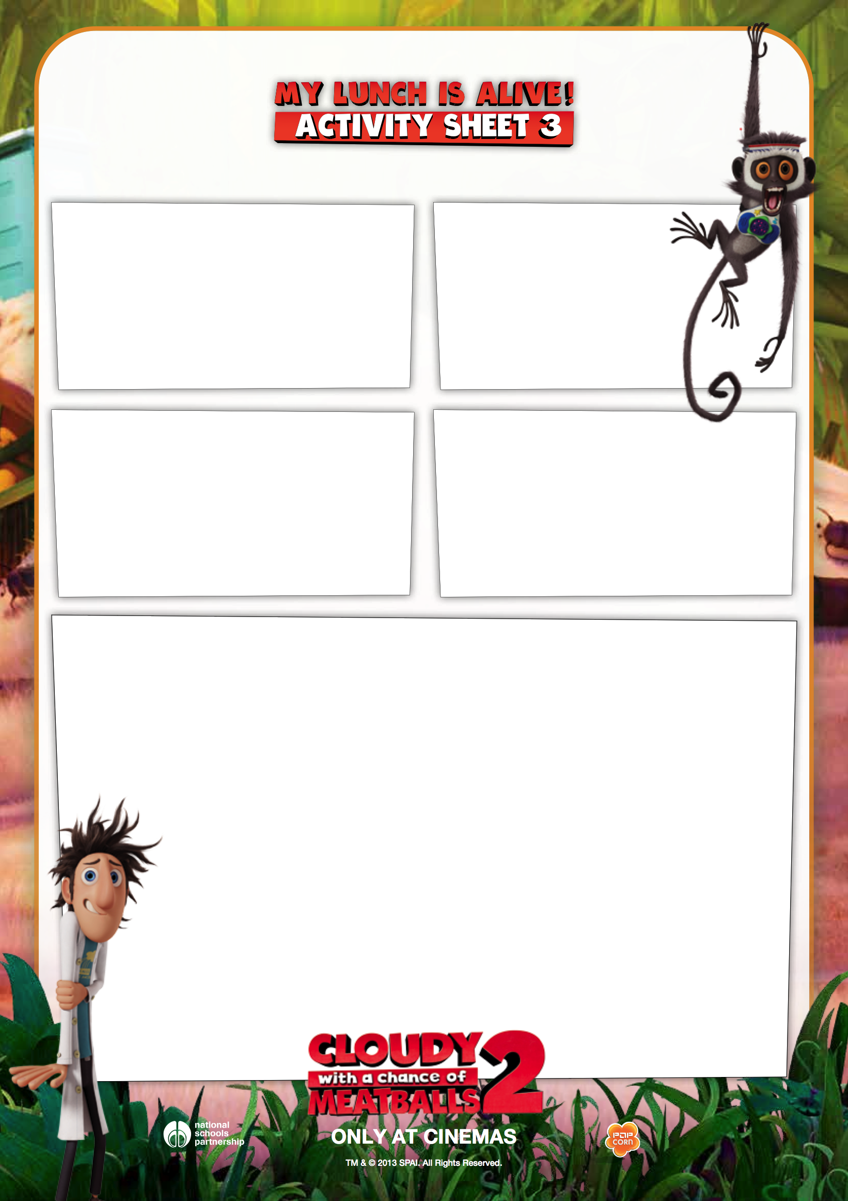

My Setting

What can you hear?

What can you smell?

What can you feel?

What can you see?