Home Learning Grid – Summer Term Week 2 |  |  | Saturn Class
Reading  Keep reading books you have at home daily-reading books more than once is always good!  Read instructions from board games you have available and pull out the different word types eg: imperative verbs, fronted adverbials etc | Writing Creative writing time!  Use the planning format to carefully draft a creative story about your lunch coming alive.  Once thoroughly planned, write a very descriptive (lots of adjectives and adverbs) story. Please e-mail me your stories, as I’m sure they will be amazing! This work doesn’t have to be completed on the sheets-it’s just to give you guidance! | Maths  Measure area and perimeter of each room in your house. If you don’t have a tape measure/ruler, you’ll have to be imaginative and use what you can find…pencils, coins, books etc.  Use these measurements to find the difference in size between two rooms.
Get Creative  Design and make a mode of transport. Think about the challenges you face and select the correct material to build eg: boat needs to float, parachute needs to be light etc.  Create a quiz for your family members to complete. Think about a topic you could generate questions about eg: space, animals etc.  Design a statue to say thanks to the NHS and key workers that could be placed in the city centre. | Science  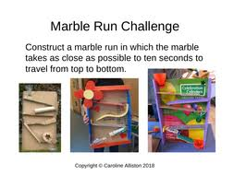  You can look online for inspiration! | Get Active  Design a ‘Joe Wicks’ style dance/aerobics workout! Get someone in your family to video you/ record it yourself then challenge your family members to complete the workout.
PSHE & Life Skills

Think about qualities you like about a member of your family. Create an acrostic poem about them that will make that person smile! You could also do this about yourself….be positive!

