Home Learning Grid – Summer Term Week 5 |  |  | Saturn Class
Reading  Keep reading books you have at home daily-reading books more than once is always good!  Read recipes from books or online. Look for fronted adverbials and imperative verbs (bossy verbs). | Writing Creative writing time!  Write revolting recipes for different fictional characters, the characters can be from books, films, cartoons etc.  Give your recipe an alliterative title ie: Muddy mammoth meatballs with squelchy stinking spaghetti!  Don’t forget to include your ingredients and a picture (draw) alongside your instructions. | Maths  Write different problem solving questions ie: I went to the shop and bought 5x carrots at 35p each, chicken legs at £3.49 and potatoes at £1.19 I paid with a £20 note how much change did I get?  Send me your questions and I will answer them!
Get Creative  Draw and colour/paint a picture A4 size then cut up into pieces and challenge someone in your house to put the pieces back together again.  Make a 3D sculpture of yourself….use objects around the house.  Go for a walk with your family, collect objects (flowers, grass, twigs etc) to create an image/scene from your walk.  Send in your photos to be displayed on the school website. | Science  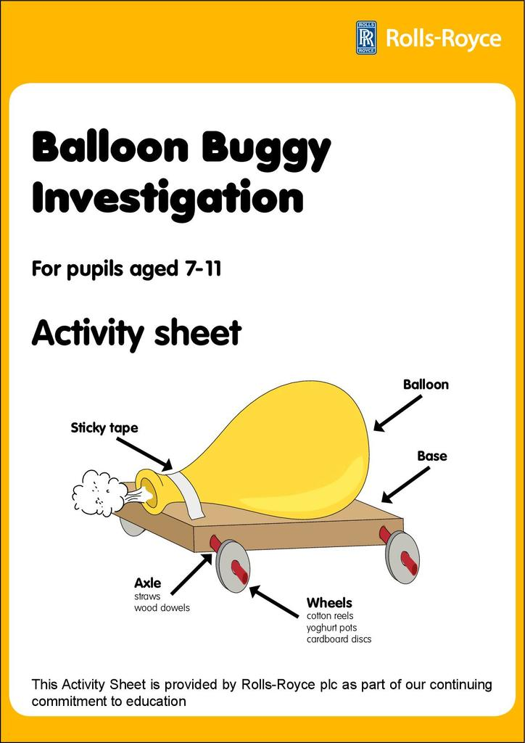  Create a balloon buggy this is just an example you can use what ever you like to make the buggy but you will need a balloon! | Get Active  Make a dance routine to your favourite song. Get others in your house to join in!
PSHE & Life Skills

Make someone smile in your house. Make them a cup of tea-ask permission first, a sandwich or help out with the house work by making the beds, hoovering the carpets etc.

