Home Learning Grid – Summer Term Week 6 |  |  | Saturn Class
Reading:  - Use read theory daily.  - Read a chapter a day of a book/magazine you haven’t read yet.  - Read and write the spellings for your year group. Practice daily.  - Use the spelling menu to be creative with your spellings. | Writing:  - In school, we are working on creating a history display all about Corona virus.  - This week’s writing/creative tasks are:  To take photos of things that have changed in our world (signs etc) and create a college,  Write instructions on how to enter school or somewhere similar,  diary entry of a creative day in lockdown,  Draw a picture of yourself with emotion words/emoji’s and examples of times they have felt these during lockdown.  This will be an amazing history display so please send in your work then it can be displayed in school! | Maths:  - Use daily 10 on top marks https://www.topmarks.co.uk/maths-games/daily10  - Target 1000 roll a dice 6 times/ choose 6 random numbers. Use the six digits to make two three-digit numbers. Add the two numbers together. How close to 1000 can you get?  - Four in a line Draw a 6 x 7 squares grid. Fill it with numbers under 100. Take turns. Roll three dice, or roll one dice three times. Use all three numbers to make a number on the grid. You can add, subtract, multiply or divide the numbers, e.g. if you roll 3, 4 and 5, you could make 3 x 4 – 5 = 7 and so on. Cover the number you make with a coin or counter. The first to get four of their counters in a straight line wins.
Creative:  - Create a inner and outer self portrait (see attached sheet for example/template). Base the inner self side on your feelings today-be creative, send in a photo of your creation for our lockdown display!  - Use Graffiti style writing to create an emotive word display, colour using bold and bright colours-send in pictures of your picture. | Science:  SKITTLE SCIENCE  Add some skittles to water and watch what happens, can you see the colours seep into the water? Does the ‘S’ separate from thesweet? 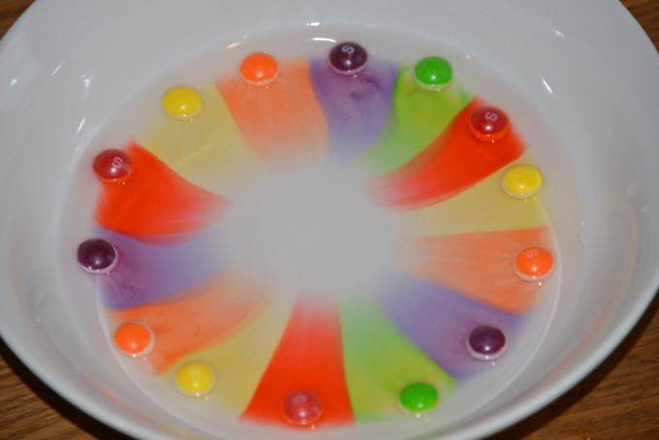 Try using a different liquid, observe what happens. Or different sweets! | P.E:  - Go for a walk/run with a grown up every day.  - Create a fitness workout.  - Put your favourite song on and dance like no-one is watching!  - Create a go-noodle account and complete some activities.

